### University of Massachusetts

Department of Electrical and Computer Engineering

Academic Year 2020-2021

Senior Capstone Design Course Project Description

**Title:**

# Multi-lateration localization in GPS denied zones

#### **Customer/ Sponsor:** *Prof. Paul Fortier*

#### **Customer Company/Org:** *Prof. Fortier, ECE department*

**Customer Contact Information**

**Name (if not the same as above)**

**email**  pfortier@umassd.edu

**Phone No(s) 508-999-8544 (email or zoom meetings are preferable)**

**Project Description and Need:**

Design and build an embedded systems application that utilizes commercial off the shelf (COTS) wireless transmitters and receivers to implement a multi-lateration localization algorithm and system. The goal of the system is to support the monitoring of a target of interest (e.g .robot, drone, etc.) that emanates a transmission signal that when picked up by 4 or more listening nodes can be used to compute the location of the target and track to target over time.

**Objectives:**

This project includes

* Understanding the problem and why it is important
* Develop a concept for localization of targets on the ground and in the air.
* Specifying the requirements for sensors, transmitters, receivers, data acquisition, data processing, localization concept.
* Prototyping and testing the system in the lab
* Hand held or laptop based application to aid in tracking targets of interest.

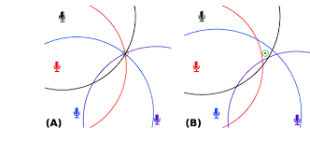

Example multi-lateration localization arcs

**Resources:**

The ECE department will provide some small fixed amount (~$500) for the purchase of components.

#### **Faculty Advisor** *< Suggested Faculty Advisor; if not known leave blank>*